USER MANUAL

For

Module: Electricity Billing

Introduction – Electricity Billing

The Electricity Billing Module is a computerized system designed to automate and simplify the process of electricity billing and consumer management. This module helps electricity departments, utility providers, and organizations efficiently manage customer information, meter readings, bill generation, payment records, and reporting activities.
The purpose of this user manual is to provide users with a clear understanding of the features, functions, and operational procedures of the Electricity Billing Module. It serves as a step-by-step guide for administrators, billing operators, and end users to effectively use the system without technical difficulty.
The module enables users to:
- Manage consumer registration and profiles
- Record and update meter readings
- Generate electricity bills automatically
- Calculate charges based on tariff rates
- Track payments and outstanding dues
- Generate reports and billing summaries
- Maintain accurate and secure billing records
This user manual includes detailed instructions for system login, dashboard navigation, consumer management, billing operations, payment processing, report generation, and troubleshooting. The manual is intended to improve user efficiency, reduce operational errors, and ensure smooth functioning of the billing process.
The Electricity Billing Module is designed with a user-friendly interface, secure database management, and automated workflows to provide accurate, transparent, and reliable billing services. It supports both manual and smart meter-based billing systems and can be integrated with online payment platforms for enhanced customer convenience.

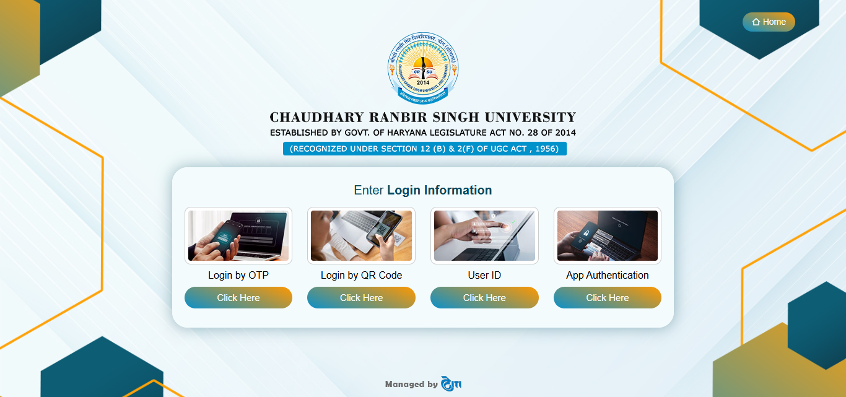

Login Page
The Login Page is the entry point for authorized users to access the system of Chaudhary Ranbir Singh University. It provides multiple secure authentication.
Key Features of the Login Page
- Login Information Section:
The center panel titled “Enter Login Information” provides different authentication methods for users to log into the system.
- Login by OTP:
Users can log in using a One-Time Password (OTP) sent to their registered mobile
number or email for secure authentication.
- Login by QR Code:
This option allows users to authenticate by scanning a QR Code using the authorized mobile application or device.
- User ID Login:
Users can access the system using their assigned User ID and Password.\
- App Authentication:
This method allows login through a secure mobile authentication application, providing an additional layer of security.
- Click Here Button
Each login method includes a “Click Here” button that redirects the user to the respective authentication process.
- Home Navigation
The Home button available on the top-right corner allows users to navigate back to the system’s main homepage.

Navigation to Electricity Billing Module:
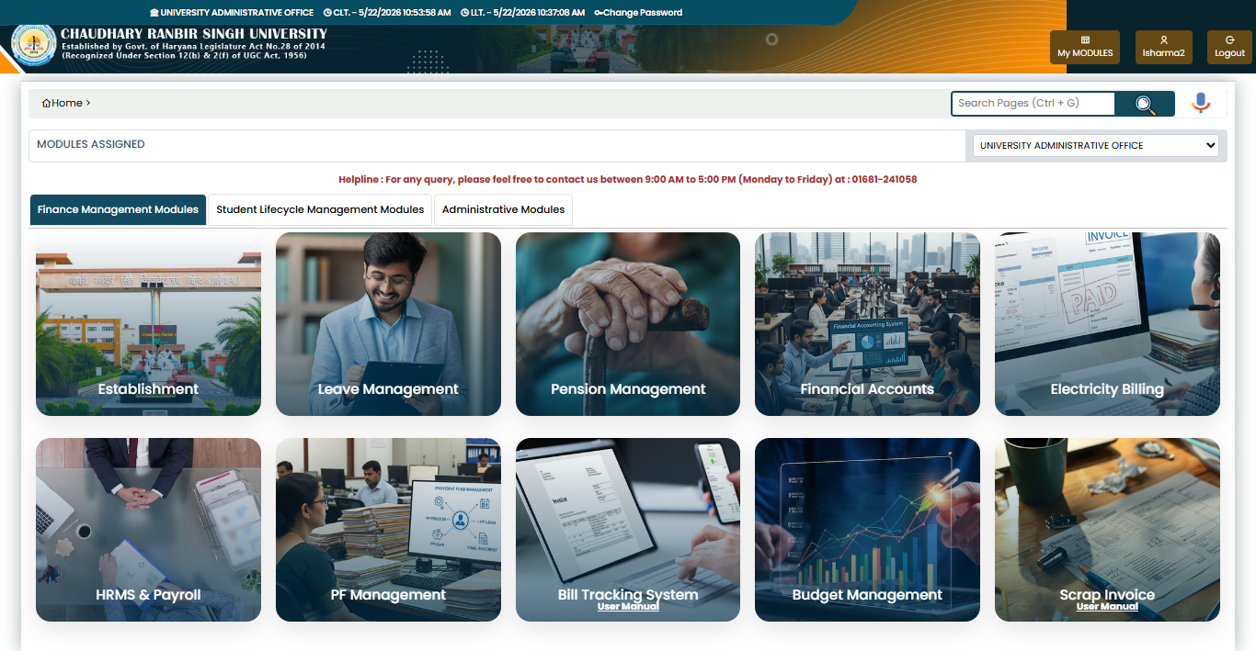
Click Here
After logging into the Chaudhary Ranbir Singh University system, navigate to the
Software Development Life Cycle section.

- Under this section, open the Finance Management section tab.
- Locate the Finance Management section from the list of available modules.
- Click on the Electricity Billing tile to proceed.
- The system will redirect you to the Student Verification page for further actions.
- Ensure you have the required permissions to access this module.
- Use the Search Pages (Ctrl + G) option if the module is not easily visible.

Electricity Billing Module section:
Electricity Billing Module Divided into the two section
- Electricity Master
- Electricity Transaction

- Electricity Master: The Electricity Master section is used to create and manage master data for the Electricity Billing Module. It consists of two types of masters that help in maintaining and configuring the billing system efficiently. These masters are used to store essential information required for electricity billing operations, calculations, and system management.
- It consist of two pages:
- Tenant Master 2. Meter Master
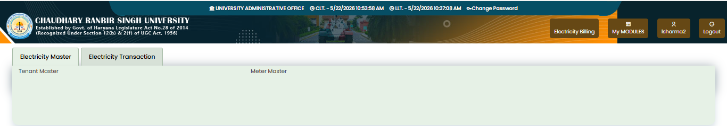

- Electricity Transaction: This section is used to create the bill bases on the unit of consumption and Tariff rate , generate the bill payment report , upload the offline payment challan.
- It consist of three Pages
- Bill Creation 2. Bill Payment Report
3 Offline payment challan upload

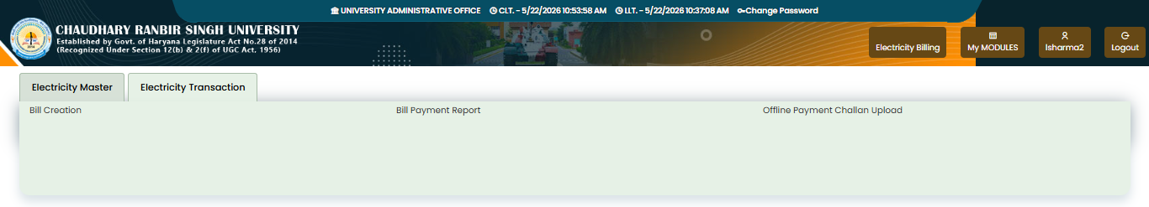
- Electricity Master

  - Tenant Master: Tenant Master page is used to manage tenant details in the Electricity Billing Module. This page helps maintain accurate tenant records for electricity bill generation and management.
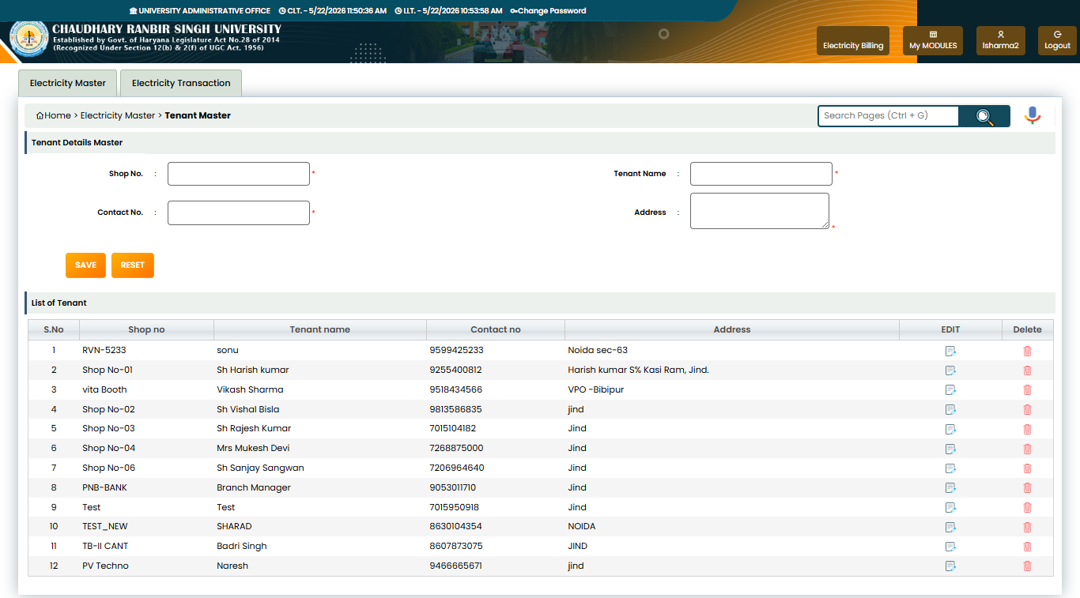
• Enter the Shop No. of the tenant in the provided field.
• Enter the Tenant Name for identification purposes.
• Enter the Contact No. of the tenant for communication.
• Enter the complete Address of the tenant.
• Click on the Save button to store tenant details.
• Click on the Reset button to clear all entered data.
• The List of Tenant section displays all saved tenant records.
• The Edit option is used to update existing tenant information.
• The Delete option is used to remove tenant records from the system.
• The Search box helps users quickly find records or pages.
• Breadcrumb navigation helps users identify the current page location.

  - Meter Master: Meter Master page is used to map meter numbers with shop numbers in the Electricity Billing Module. This page helps maintain accurate meter mapping for electricity consumption tracking and bill generation.

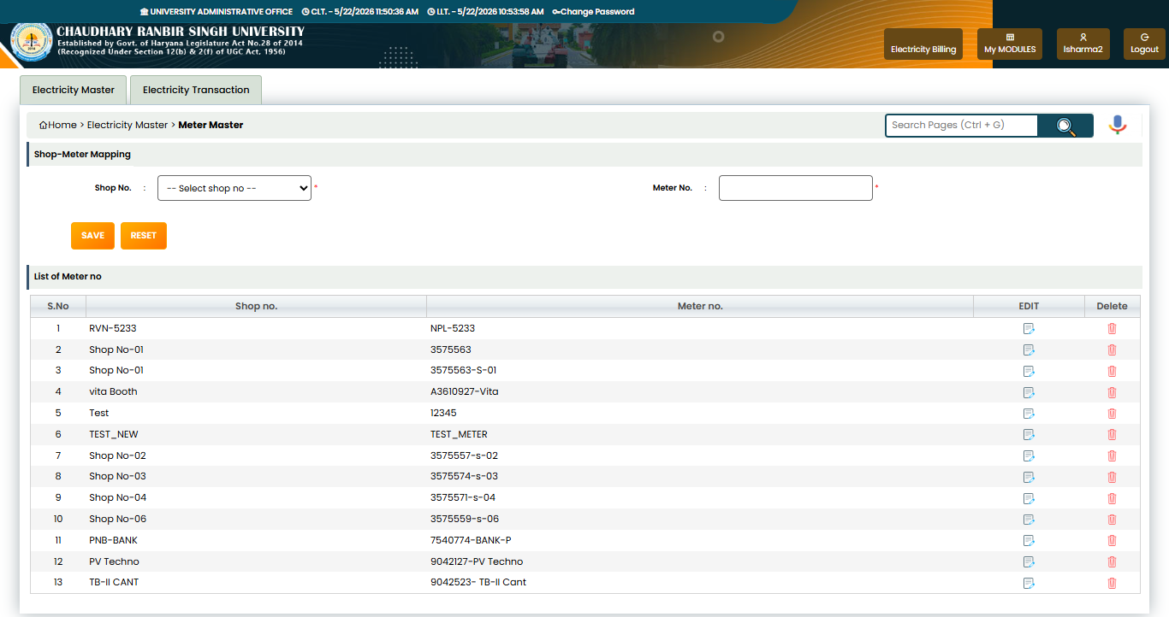

• Select the Shop No. from the dropdown list.
• Enter the Meter No. in the provided field.
• Click on the Save button to store meter mapping details.
• Click on the Reset button to clear entered information.
• The Shop-Meter Mapping section is used to link a meter with a specific shop.
• The List of Meter no section displays all saved meter records.
• The Edit option is used to update existing meter details.
• The Delete option is used to remove meter records from the system.
• The Search box helps users quickly find records or pages.
• Breadcrumb navigation shows the current page location for easy navigation.

- Electricity Transaction
  - Bill Creation: Bill Creation page is used to generate electricity bills for tenants based on meter readings. This page is used for electricity bill generation, billing management, and payment tracking in the Electricity Billing System.
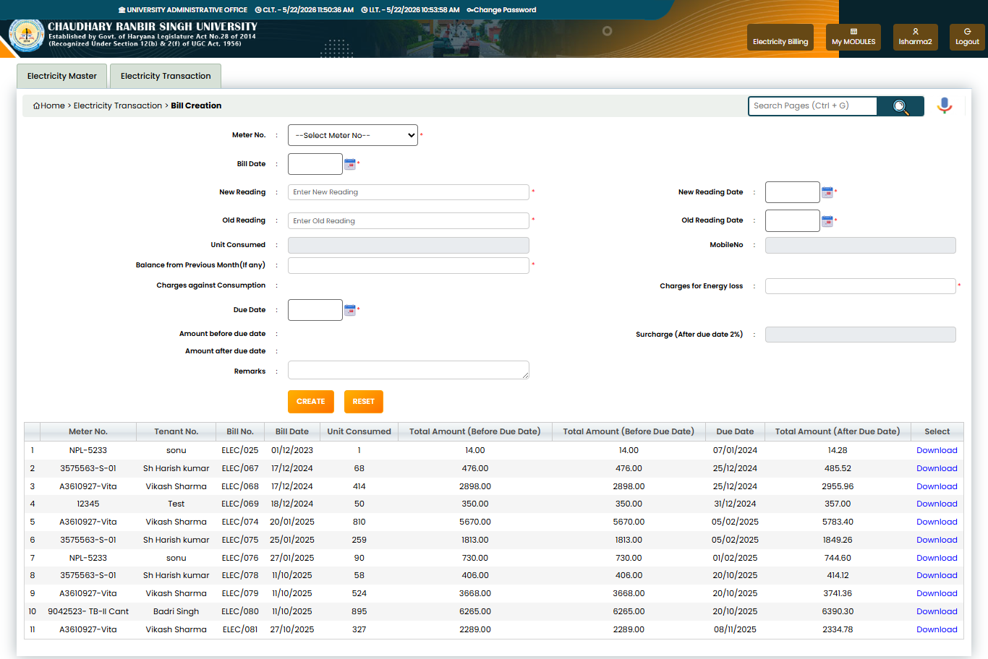

• Select the Meter No. from the dropdown list.
• Select the Bill Date using the calendar option.
• Enter the New Reading of the electricity meter.
• Enter the Old Reading of the electricity meter.
• The system automatically calculates Unit Consumed based on meter readings.
• Select the New Reading Date for the current meter reading.
• Select the Old Reading Date for the previous meter reading.
• The Mobile No. field displays the tenant contact number.
• Enter the Balance from Previous Month (if any) for pending dues.
• The system calculates Charges against Consumption based on consumed units.
• Enter or verify Charges for Energy Loss if applicable.
• Select the Due Date for bill payment.
• The system calculates the Amount before Due Date automatically.
• The system calculates the Surcharge (After due date 2%) automatically.
• The system calculates the Amount after Due Date including surcharge.
• Enter remarks in the Remarks field if required.
• Click on the Create button to generate the electricity bill.
• Click on the Reset button to clear all entered details.
• The bill list section displays all generated electricity bills.
• The grid shows Meter No., Tenant Name, Bill No., Bill Date, Unit Consumed, Due Date, and Bill Amount details.
• The Download option is used to download or print the generated electricity bill.
• The Search box helps users quickly find records or pages.
• Breadcrumb navigation helps users identify the current page location.

1,2 Bill Payment Report : ]Bill Payment Report page is used to view and track electricity bill payment details. This page is used for monitoring bill payments, transaction tracking, and generating electricity payment reports in the Electricity Billing System.

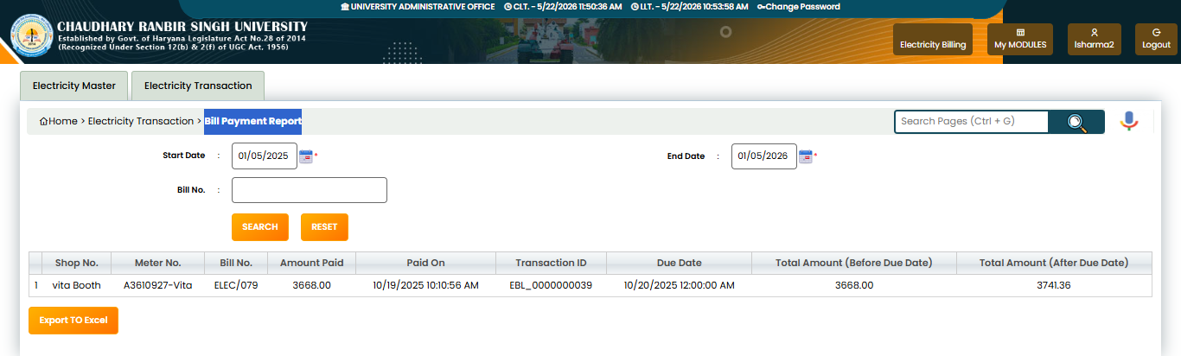
• Select the Start Date to view payment records from a specific date range.
• Select the End Date to filter payment records up to a specific date.
• Enter the Bill No. to search a specific bill payment record.
• Click on the Search button to display payment report details.
• Click on the Reset button to clear all entered search criteria.
• The report grid displays all bill payment records in tabular format.
• The Shop No. column shows the shop or tenant location number.
• The Meter No. column displays the associated electricity meter number.
• The Bill No. column shows the generated bill number.
• The Amount Paid column displays the paid bill amount.
• The Paid On column shows the payment date and time.
• The Transaction ID column displays the payment transaction reference number.
• The Due Date column shows the last payment date of the bill.
• The Total Amount (Before Due Date) column displays the payable amount before the due date.
• The Total Amount (After Due Date) column displays the payable amount after applying surcharge.
• Click on the Export To Excel button to download the payment report in Excel format.
• The Search box helps users quickly search records or pages.
• Breadcrumb navigation shows the current page location for easy navigation.

  - Offline Payment Challan Upload: Offline Payment Challan Upload page is used to upload offline payment challans for electricity bills. This page is used for managing offline electricity bill payment challans and maintaining payment verification records in the Electricity Billing System.
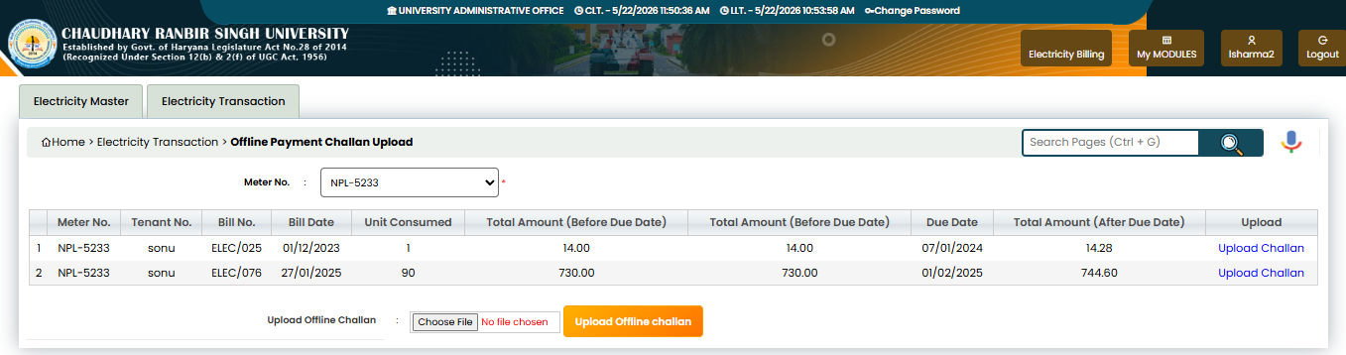

• Select the Meter No. from the dropdown list to view related bill records.
• The grid section displays all pending or generated electricity bills for the selected meter.
• The Meter No. column shows the electricity meter number.
• The Tenant No. column displays the tenant or shop name.
• The Bill No. column shows the generated bill number.
• The Bill Date column displays the bill generation date.
• The Unit Consumed column shows the total electricity units consumed.
• The Total Amount (Before Due Date) column displays the payable amount before the due date.
• The Due Date column shows the last date for bill payment.
• The Total Amount (After Due Date) column displays the payable amount including surcharge after the due date.
• The Upload Challan option is used to upload the offline payment challan document.
• Users can upload challans for maintaining offline payment records in the system.
• The Search box helps users quickly search pages or records.
• Breadcrumb navigation shows the current page location for easy navigation.

